CaseManagement_CreationOfCase_Instance23_03-Aug-2018_06-29-58_AM_MouseClickActiononStaleElement.png

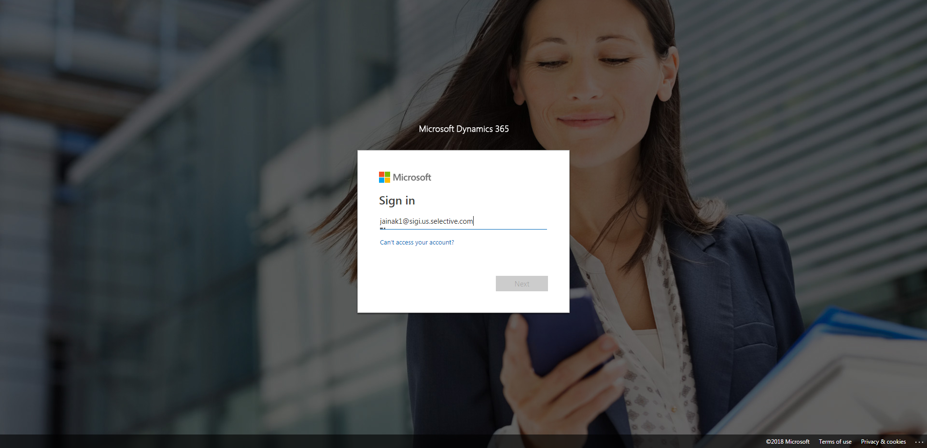

CaseManagement_CreationOfCase_Instance23_03-Aug-2018_06-32-40_AM_MouseClickActionMoveToElementByxpathimgaltServiceparentspan.png

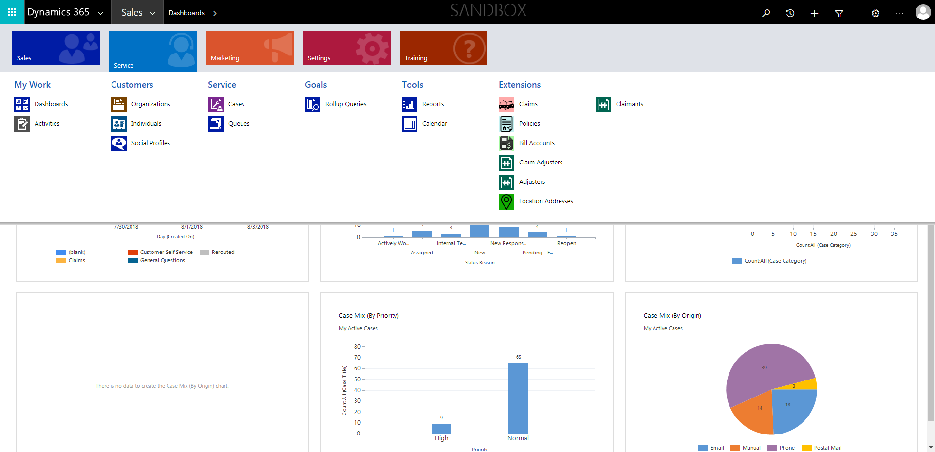

CaseManagement_CreationOfCase_Instance23_03-Aug-2018_06-32-39_AM_MouseClickActionMoveToElementBycssSelectorspanTabSFA.png

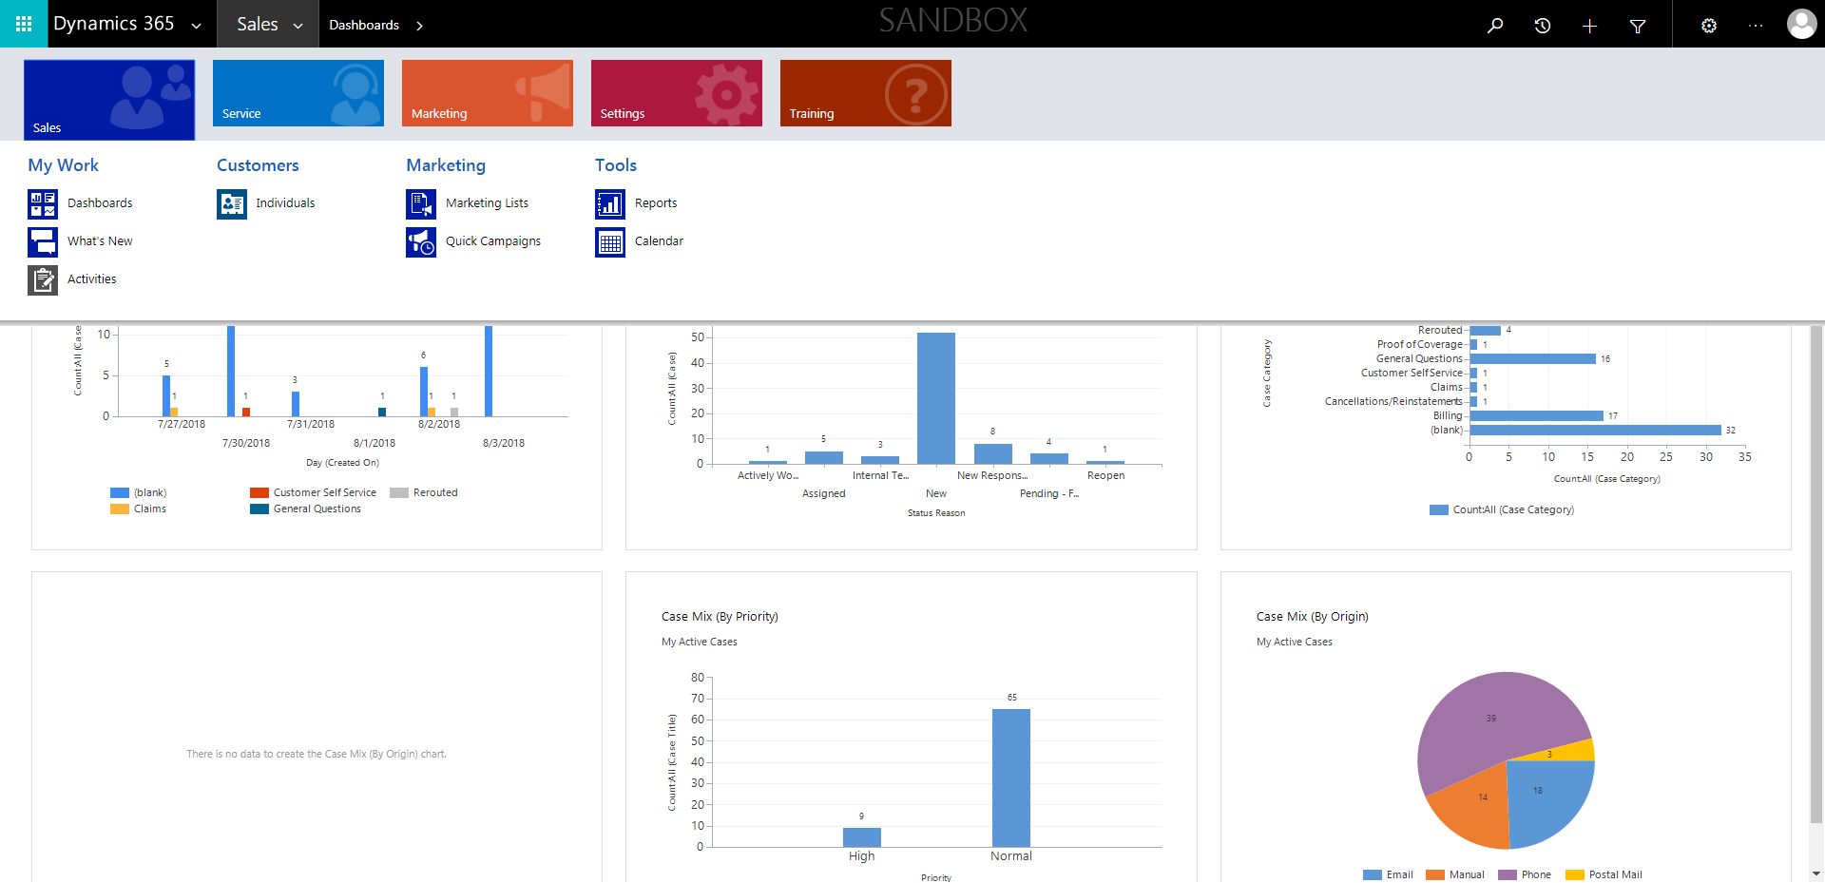

CaseManagement_CreationOfCase_Instance23_03-Aug-2018_06-29-55_AM_MouseClickActiononStaleElement.png

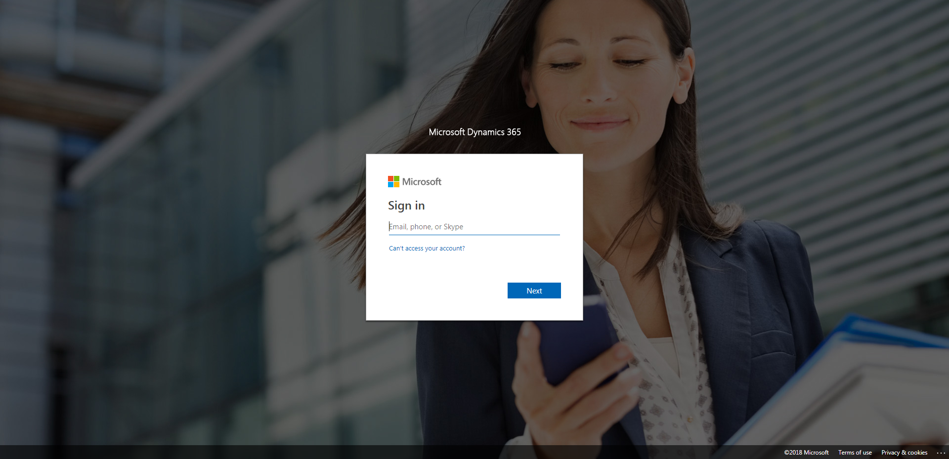

CaseManagement_CreationOfCase_Instance23_03-Aug-2018_06-32-41_AM_MouseClickActionMoveToElementBycssSelectoranavcases.png

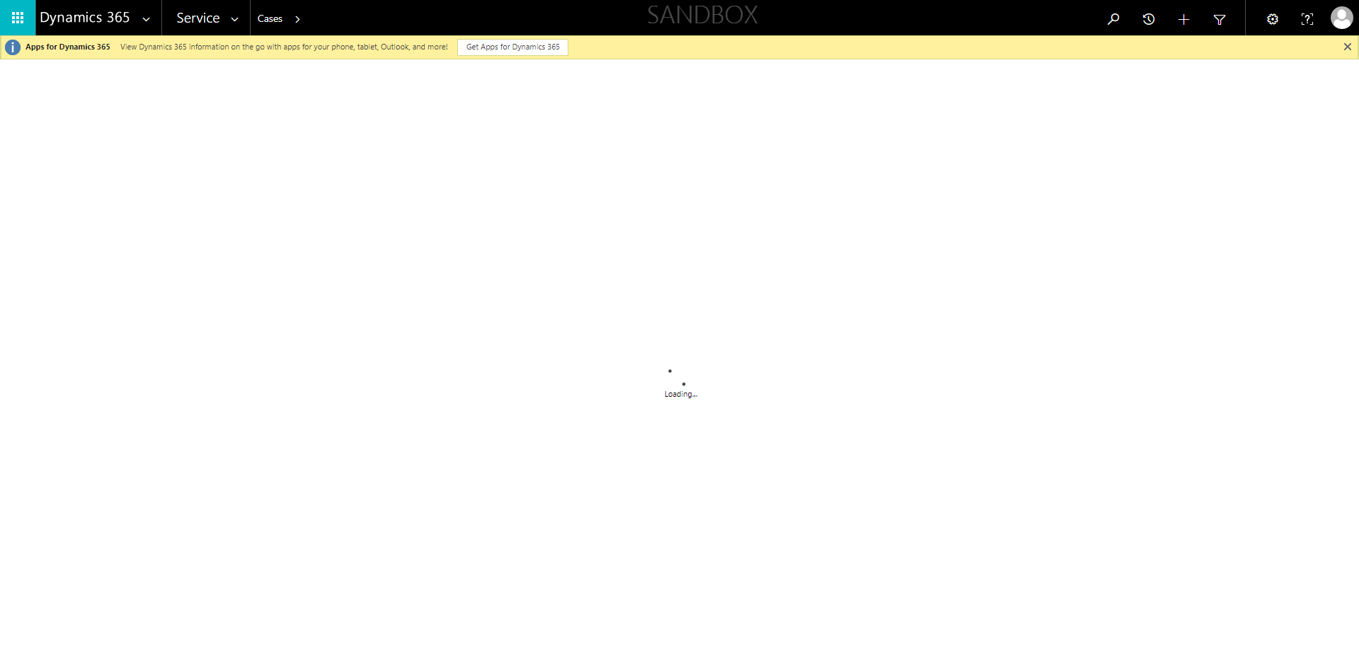

CaseManagement_CreationOfCase_Instance23_03-Aug-2018_06-29-57_AM_EnterTextAction.png

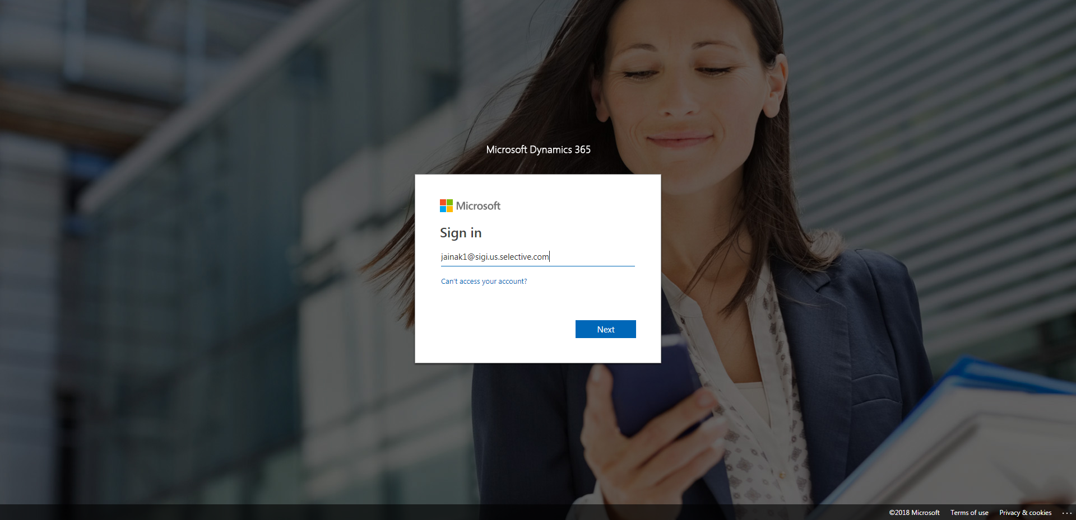

CaseManagement_CreationOfCase_Instance23_03-Aug-2018_06-32-36_AM_SingleSignOn.png

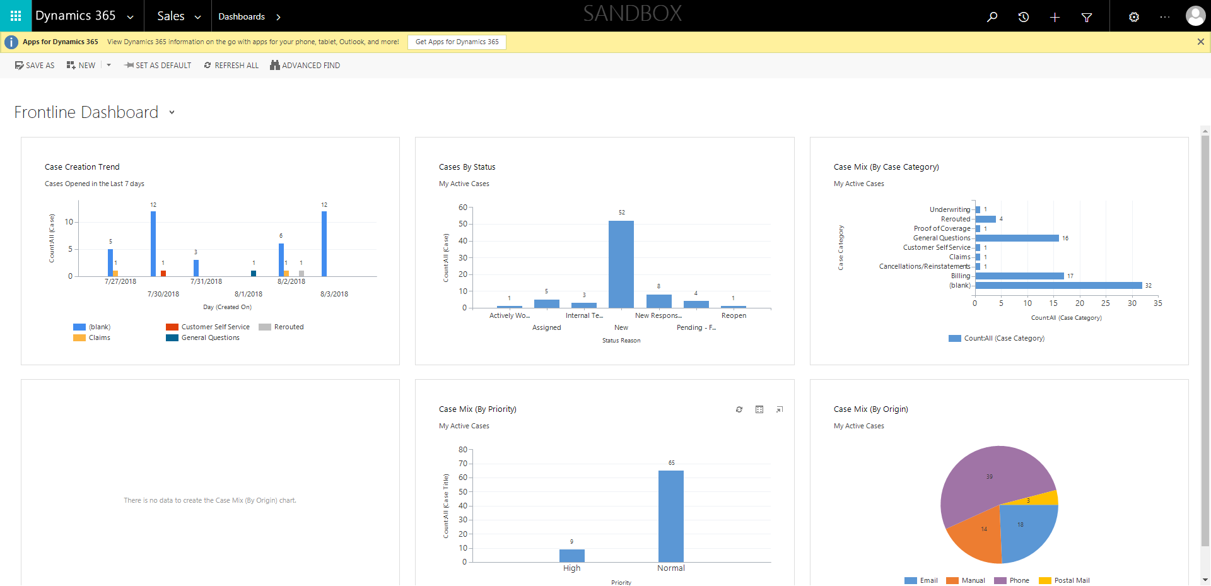

CaseManagement_CreationOfCase_Instance23_03-Aug-2018_06-32-34_AM_SingleSignOn.png

